AZ-M30
High Definition Borescope Inspection Camera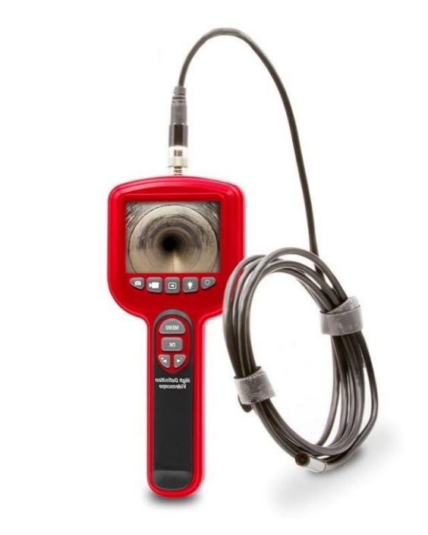
Applications
- Medical use
- Human examination
Features
- High performance industrial inspection camera with a 3-inch high definition colour LCD.
- It is ergonomically designed so that the main functional buttons can be controlled with one hand.
- The snapshot and recording functions are supported, photos and videos can be saved on TF memory card.
- Auxiliary light source and adjustable LED lights making it easy and handy to use in a dark environment.
Specifications
Screen | 3.0inch color LCD display (1080p)
Resolution | 1920*1080
Horizontal viewing angle | 60°
Video Output Format | NTSC
Image Size | Images – size (1270X 1080) and format (JPG)
Video Size | (1920 X 1080 and format (AVI)
SD Card | 4G Included (supports up to 64G)
Line length | 2M
Focal length | 1.2” to 4.0” (3cm-10cm)
Waterproof level | IP67(only for camera head and lens)
Lens diameter | 5.5mm
Battery capacity | 3000mAh
Battery life | Approximately 3-4 hours
Dimensions | 9.0*6.7*3.0” (23CM*17CM*8CM)
Weight | 1.8lb (0.8kg)

